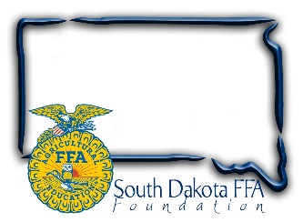
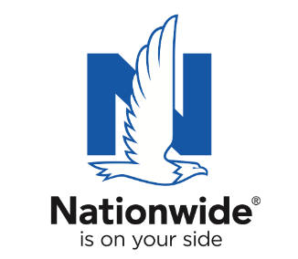
FOR IMMEDIATE RELEASE

March 7, 2023
Contact:
Gerri Ann Eide
gerri@sdffafoundation.org
605-765-4865

Nationwide:
Bethany Eippert
614-249-0682
eippeb2@nationwide.com
Agriculture Teachers Honored as SD Finalist
for Ag Educator of the Year
The Golden Owl Award® recognizes extraordinary teachers
and supports future educational efforts
Bath, SD – Agricultural educators play a crucial role in their communities, dedicating countless hours and often their own resources to preparing students for successful careers and helping them follow their interests. To shed light on the contributions of South Dakota’s leading agricultural teachers, the South Dakota FFA Foundation and Nationwide are honoring seven exceptional teachers as finalists for the Golden Owl Award.
Oct. through Dec., 2022, the South Dakota FFA Foundation and Nationwide collected nearly 200 nominations for South Dakota’s top agricultural teachers from students, parents, and community members across the state.

South Dakota’s 2022-2023 Golden Owl Award finalists are:
District 1: Jim Chilson, Florence Academy (pictured with April Hamilton, SD FFA Association)
District 2: Kelly Keller, Arlington (pictured with Arlington FFA members and April Hamilton, SD FFA Association)
District 3: Bridget Twedt, Beresford (pictured with Don Riley, Nationwide rep and April Hamilton, SD FFA Association and Beresford School board member Russell Johnson)
District 4: Mark Misar, Bon Homme (pictured with April Hamilton, SD FFA Association)
District 5: Tana White, Hot Springs (pictured with Wyatt DeJong, SD FFA Association and Natacha Artz, Nationwide rep)
District 6: Noelle Swanson, Northern Area (pictured with Amy Heim, Nationwide rep and Gretchen Sharp, SD FFA Foundation)
District 7: Andrew Jensen, Sioux Falls CTE Academy (pictured with Don Riley, Nationwide rep and April Hamilton, SD FFA Association)

Each finalist was presented with an individualized plaque in front of fellow teachers and students and received a $500 donation to support future educational efforts. Next, they’ll be entered into a final selection stage for the chance to be crowned as South Dakota Ag Educator of the Year, earning an additional $3,000 Nationwide-funded check to help boost their programs and the coveted Golden Owl Award trophy. The winner will be announced during the SD FFA Convention, April 18th, in Brookings, SD.

“Our teachers are the foundation of the FFA. They inspire our members every day, providing them encouragement and motivation to try new things. They coordinate early morning practices, dedicate weekends to FFA events, model a passion for serving others, and endlessly help students grow their passion for agriculture. We are so thankful Nationwide recognizes the valuable work our teachers do and provides this award.”

Nationwide established the Golden Owl Award to honor the contributions of teachers and support their programs with additional resources to assist their continued educational efforts. This year, the award program honors outstanding ag educators in nine states: California, Illinois, Indiana, Iowa, Nebraska, New York, Ohio, Pennsylvania and South Dakota.

“The Golden Owl Award seeks to thank agricultural teachers for the extraordinary care they bring to their work as they go above and beyond in educating America’s youth and future leaders,” said Nationwide’s agribusiness president, Brad Liggett. “We are proud to honor their contributions, highlight the growing need for their services, and supply additional resources to help benefit their programs and students.”

In conjunction with the Golden Owl Award, Nationwide is also donating $5,000 to the South Dakota FFA Foundation to further support the personal and professional growth of students, teachers and advisors alike.

About Nationwide
Nationwide, a Fortune 100 company based in Columbus, Ohio, is one of the largest and strongest diversified insurance and financial services organizations in the United States. Nationwide is rated A+ by both A.M. Best and Standard & Poor’s. An industry leader in driving customer-focused innovation, Nationwide provides a full range of insurance and financial services products including auto, business, homeowners, farm and life insurance; public and private sector retirement plans, annuities and mutual funds; excess & surplus, specialty and surety; pet, motorcycle and boat insurance. For more information, visit www.nationwide.com. Follow us on Facebook and Twitter.

About SD FFA
The SD FFA has 5500 members in 110 high school agriculture education programs. The SD FFA Foundation is proud to support Agricultural Education and the FFA's mission to make a difference in the lives of students by developing their potential for premier leadership, personal growth and career success through agricultural education. For more information about the South Dakota FFA Foundation and South Dakota's FFA programs, visit www.sdffafoundation.org or follow us on Facebook.
###

